Bradley Lamitie

Assigned on 9/6/2016

Due on 9/13/2016

Assignment 2

Test your understanding:

1. A) Hardware Elements:

* Wireless Access Router
* Broadband Modem
* Two Hosts
* 4-pair UTP
* Tablet
* Wireless Network Printer

B) UTP (Unshielded Twisted Pair)

C)8 Pin RJ-45

D)uses 802.11, UTP or both

E) 5 hard ware functions:

1.connect two networks (home and ISP)

2. have at least 4 RJ-45 ports

3. Router has a wireless access point to connect to.

4. DHCP Server that gives itself an IP address

5. NAT functionality

F ) The DHCP assigns an IP address to the WAC.

G)NAT is necessary because it converts the IP source addresses to the ISP’s single allocated IP address.

H) 1. Shared Internet Access,

2. File sharing,

3. Printer Sharing

I) all client PCs, Wireless Printer, Wireless access point.

Design

1. 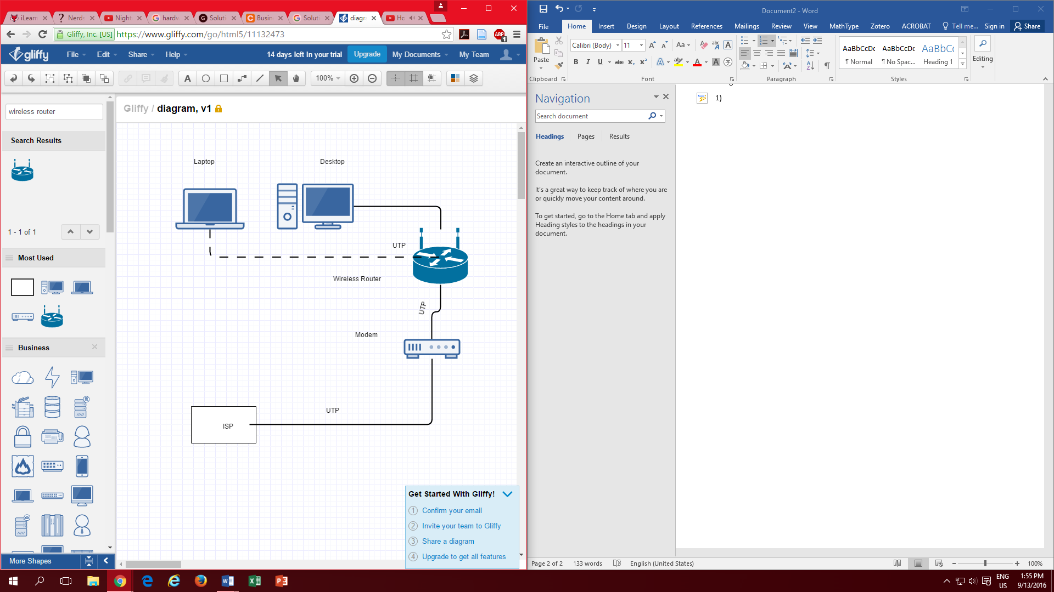

The modem is hooked to the ISP using UTP. The modem is connected using UTP to the wireless Router. The router is linked with UTP to my desktop. My laptop connects to the wireless router using a wireless connection.

Wireless access routers with 802.11ac: $149.99 Synology RT1900ac

Without 802.11ac : $29.99 TP-LINK N450 Router - Black (TL-WR941ND)

### 10 feet long USP cord: $9.99 [Livewire USB Cable 10 ft.](https://www.google.com/shopping/product/9355926695453083894?q=premade+USB+cord&espv=2&biw=764&bih=719&bav=on.2,or.r_cp.&bvm=bv.132479545,d.cWw&ion=1&tch=1&ech=1&psi=YuTYV-SRA8Ou-QHs05iADQ.1473832037094.5&prds=paur:ClkAsKraX8eY8ZYwU_Agllh7BlxSjbBK8SAurUAN8GERqXl31DPbkiUKgnZiv1BJg0766wCuVwAV9jstquQ9MSkm_D0Q65Ig49E_bUIP2K_Rcw7_I6cSjqLdlBIZAFPVH73nD9eueS6urIE88Fsep-VPn4yA9g&sa=X&ved=0ahUKEwjZp8OflI7PAhXKNj4KHfmPCkAQ8wIIlgYwAA)